Proposal for Rolsa Technologies

Cody Mac Vay

LL-00000000

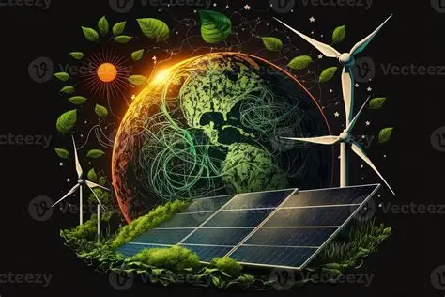

Contents
Organisation overview 3
Description of the company 3
What they do? 3
What are they looking for? 3
Problem Overview 4
Main problems 4
User Groups 5
Customers 5
Management staff 5
Uninformed customers 5
Empathy maps 6
User Stories 7
Uninformed Customers 7
Management staff 7
Current Customers 7
Laws / Guidance / Legislation 8
Data protection and privacy laws 8
Energy and environmental regulations 8
Consumer Protection and E-Commerce Laws 8
Advertising and green claims 9
Cybersecurity and Smart Device Laws 9
Database and cloud Data storage 9
Alternate Systems 10
Risks 11
1. Legal and Compliance Risks 11
2. Technical & Cybersecurity Risks 11
3. Financial & Business Risks 12
4. Operational & Performance Risks 13
5. Reputation & Trust Risks 13
6. Environmental & Regulatory Change Risks 13
7. Ethical & Social Risks 14
Decomposition 16
User Acceptance Criteria 17
Functional and Non-Functional requirements 22
Functional requirements 22
Non-Functional Requirements 23
Key Performance Indicators (KPI) 25
Energy & Efficiency KPIs 25
System Performance KPIs 25
User Engagement & Satisfaction KPIs 25
Environmental Impact KPIs 26
Description of Proposed Solution 27
Tips 28

Organisation overview

Description of the company

Rolsa Technologies is a green energy company that is looking to make use of natural energy to produce power for homes and even electric vehicles, they also specialise in smart home management systems to manage all your central heating and water etc.

What they do?

Rolsa Technologies have been looking to develop a digital system that would provide very specific information to customers regarding what green energy products are currently on the market as well as how much they could remove their carbon footprint, this will allow Rolsa Technologies customers to have a more structured system which would allow them to work around their busy schedules. In the development of the new system the customers will be able to schedule consultations and installations of their products and this will be at the customers discretion and whenever they may be available, it should also allow the customers to be able to calculate their carbon footprint and track their difference between the before and after the use of green energy that is provided.

What are they looking for?

Rolsa Technologies are looking to develop a digital system to make there company run far more efficiently as well help their customers with an easier way of looking for products or booking consultations or installations, this will allow for a more flexible and easier way of managing the business as well for a management director. It will also allow for everything to be stored in one place and digitally which means less paperwork and filing and a much easier way to access your details as a customer.

Problem Overview

Main problems

My understanding of the problem is that Rolsa Technologies do not have a digital system or are looking to upgrade their systems due to newly emerging technologies. The problems they are facing is that there customers are unable to view current products on the market nor are they able to track or see their carbon footprint, another problem could be that they are still using a paper system and are not fully able to store customers details, orders or bookings in a system which would allow for an easier management system.

The impact these problems are currently having on the company could be an issue with management as they will not have a structured system for bookings or orders as well as they wont be able to have customers details stored, for example if a customers product was to be running late on delivery there would not be a way to inform the customer of this issue, another way this could impact the company, is if the customer had some sort of emergency or something was to come up there is not a way for the customer to change or alter the booking or even just delete their booking which can cause issues from the customers perspective as well as the companies one.

The current problem to my understanding is that they are a company with very little digital systems or operative ones and are in desperate need as the company could potentially be growing faster than they might of expected.

User Groups

There are 4 main user groups that should be able to access this new digital system.

Customers
Customers should be able to use this system to few the various new or even current products that are on the market as well as be able to few and compare prices of these current or new products. The new system should allow for the customers to even track their carbon footprint.
The new system will be well documented and will be well commented and good instructions to make it readable and fair for all ranges whether they are good at using technology or even if they are not this system will be easy to use and read. Most of the customers should have a decent job or employed as the market for green energy may not be the cheapest especially because Rolsa Technologies specialises in electric vehicle (EV) charging stations, solar power installation and maintenance as well as smart home management system, meaning that the market is not the cheapest. For older age ranges they might not understand technology as much as the younger age ranges.

Management staff
Management staff should be able to use this system to be able to manage the consultations and installation bookings to make sure that they can get a consultant on site for the customers as well as making sure that they all on time. They can also use this system to manage the customers information ans make sure that they are stored safely for example, the passwords are hashed on the database so that it lowers risks of other people being able to access customers details and personal information.

Uninformed customers
The new system can be used by new customers who have little to no knowledge of green energy to help build an understanding of what green energy is and how it may be used in their homes. It can also help to educate them about their carbon footprint and what they can do to track their carbon footprint. They will also be educated on the pros and cons of green energy and they can make a decision whether they want to move to it or not.

Empathy maps

Says  - I need more information regarding green energy and carbon footprint.  - Could I get information to help educate myself on green energy and carbon footprint.  - Could I book my products and my installation for the same day as the arrival of my products.  - Could I create an account to manage my bookings and will I be able to cancel my bookings if something was to come up. | Thinks  - I wish there was a website that could explain what carbon footprint and green energy is and how it all works  - It would be so much easier if I could buy my products and book and installation at the same time  - I would rather order my products and book my installation for a week after the products arrival just to be safe and make sure there is definitely  a booking available.  - I wish I can create my own personalised account to be able to manage my purchases and bookings.
Does  - Looks at green energy and carbon footprint with little to no knowledge.  - Looks at website and is not well readable, so difficult to understand.  - Looks to book ahead but bookings do not show more than 2 weeks. | Feels  - Overwhelmed.  - Confused does not understand anything.  - Annoyed because they can not book an appointment in advance.  - Willing to be reassured that the website can educate.

User Stories

Uninformed Customers
As a first time customer I want to be able to visit a website and find some information on how green energy works and what it is used for, as well as learn about carbon footprint so that I can look at signing up to track my carbon footprint or even order some products. The system should allow customers to see a clear navigation bar at the top that is easy to find, this navigation bar should be locked behind a login to secure the users information for security as well as it makes it harder to access everything unless the user is logged in.

Management staff
As a management user I want to be able to access information on the website that will be able to make my life ever so slightly easier by being able to view customers booking times and where its an installation or consultation, so that I can make sure the customers get the exact services that they require and deserve. The system should allow me to login in via the navigation bar which should be locked behind the login, the system should recognise that I have logged in as a management account and display different things in the navigation bar compared to the normal customers navigation bar, for example I should be able to go in a view all the bookings for any user not just one, I should also be able to view whether they have been moved and when that date its moved to and I should also be able to see if the bookings have been cancelled. Non-functional requirements can be that there is a way to contact the customer through the system straight to their account that they have created if there was any issues regarding getting a consultant out to install their products or whatever the case may be.

Current Customers
As a current user I want to be able to access my information on the system and any of the new products or upgrades to my current ones, so that I can compare the difference between my current products and the newer products. The system should allow me to view the navigation bar that is locked behind a login, which should then display my bookings and previous bookings and purchases.

Laws / Guidance / Legislation

Data protection and privacy laws
UK GDPR (General Data Protection Regulation)
The GDPR protects how personal dad is collected and processed and stored.
The users data will be stored in a database that will be locked behind passwords or only one entry so its harder to get into. The data that will be collected from the users is the bare minimum just for logins and potentially addresses for delivery of their products. This information such as the users passwords will be hashed, the hashing is a one way hash meaning that it can not be decrypted off the database.
Data protection Act 2018 (DPA 2018)
This works alongside the UK GDPR
Penalties for non-compliance can be a fine of up 17.5 million pounds or 4% of annual global turnover, they can also require yo to stop processing data, which could shut down your service.

Energy and environmental regulations
Ofgem regulations (Office of Gas and Electricity Markets)
Ofgem regulates the UK electricity and gas markets, with our system integrating with EV charging we need to ensure that we are compliant with SMETS (Smart metering Equipment Technical Specifications), as well as adhere the data access rules under SEC (Smart energy code).

Consumer Protection and E-Commerce Laws
Consumer rights act 2015 requires us to ensure that the customers get good service of our system, all advertisement are matching to what we actually display on the system. Need to ensure that there is a clear refund and warranty process in place to give the customers that little bit more reassurance about purchasing the products.

Consumer contracts regulations 2013 ensures that every customer should receive all the information before they purchase the product as well as a 14 day right to cancel or return any products

E-Commerce Regulations 2002 makes sure that we display the company name and contact details as well as displaying decent terms and conditions and privacy cookies. This should be applied to the system and if in future there is a mobile app it should be applied there too.

Advertising and green claims
Green claims code by the CMA (Competition and market authority), this ensures that environmental sustainability claims are truthful and evidence-based which should be displayed on the system. It should also be proven that the products on the system are eco-friendly, carbon neutral or saves energy in way or form.

Cybersecurity and Smart Device Laws
Product security and telecommunications infrastructure (PSTI) act 2022
This applies to any smart devices that the system is to display or offer such as the (EV) Electric Vehicles or connected smart home systems. The system should warn the customers to ban default passwords, implement a means for vulnerability reporting.

NCSC Cybersecurity Guidelines should ensure that there is the use of HTTPS, encrypts sensitive data, protects APIs and implements secure login and MFA.

Database and cloud Data storage
Make sure that the data that is stored for the systems is stored under the UK legislations and ensure that it is compliant with the UK GDPR.

Alternate Systems

Risks

1. Legal and Compliance Risks
Operating in energy and data management exposes you to complex regulations

Key risks:
- Non-compliance with privacy laws(e.g., GDPR, CCPA)
  - Risks of heavy fines up to 20 million pound fine or 4% annual global turnover
- Misleading green claims
  - Regulatory action or lawsuits if products are not as eco-friendly as advertised
- Energy and electrical standards breaches
  - Selling or integrating non-certified equipment can result in product bans and liability
- Contractual liabilities
  - Disputes with suppliers, users, or data processors if terms are not clearly defined.
- Data residency violation
  - Storing user data outside approved jurisdiction, for example storing EU data in the US without safeguards

Mitigations:
- Work with a compliance consultant or legal advisor.
- Maintain a data protection impact assessment (DPIA).
- Publish clear privacy and cookie policies.

2. Technical & Cybersecurity Risks
Green energy and smart home systems rely heavily on connected hardware and cloud platforms.

Key risks:
- Data breaches & hacking: Unauthorised access to user data (energy usage, personal info, device controls).
- IoT vulnerabilities: Smart meters, chargers, or home systems can be exploited if not properly secured (weak passwords, outdated firmware).
- System downtime: Cloud server outages can disrupt EV charging or energy monitoring services.
- Integration failures: Compatibility issues between different manufacturers’ devices or APIs.
- Data loss or corruption: Improper backups or sync errors may destroy user or product data.
- Denial-of-service (DoS) attacks: Could knock your system offline, impacting user trust.
Mitigation:
- Use end-to-end encryption, regular software updates, and penetration testing.
- Employ secure APIs and multi-factor authentication.
- Host data in ISO 27001-certified cloud infrastructure.

3. Financial & Business Risks
Even sustainable startups can face instability.

Key risks:
- High infrastructure costs: Hosting, data storage, and device integration can be expensive.
- Slow adoption rates: Green tech uptake may depend on incentives or regulation changes.
- Market competition: Big players (Tesla, Siemens, Google Nest, etc.) dominate the ecosystem.
- Supply chain dependency: Product listings or integrations may rely on third-party availability.
- Revenue instability: If using affiliate links or ads, commissions and partnerships can fluctuate.
Mitigation:
- Diversify revenue streams (subscriptions, analytics services, integrations).
- Start with a minimum viable product (MVP) to test market fit.
- Monitor cash flow and pursue green innovation grants or carbon credits.

4. Operational & Performance Risks
Green energy systems must be reliable and user-friendly.

Key risks:
- System inefficiency: Poor optimisation could waste energy rather than save it.
- Inaccurate data readings: Faulty sensors or data models can mislead users.
- User dissatisfaction: If interfaces are confusing or the data doesn’t seem trustworthy.
- Maintenance & scalability issues: Hard to update or manage as user base grows.
Mitigation:
- Conduct thorough testing & QA cycles.
- Use modular architecture for easier scaling.
- Provide transparent energy reporting to build trust.

5. Reputation & Trust Risks
Once users trust is lost, it is hard to regain, especially in green tech.

Key risks:
- Privacy or environmental scandals: Misuse of data or “green washing” claims.
- Negative media coverage: Any cyberattack or outage can harm your image.
- Poor product partnerships: If you feature non-compliant or low-quality products.
Mitigation:
- Be transparent about data use and partnerships.
- Create a clear sustainability statement.
- Maintain responsive customer support.

6. Environmental & Regulatory Change Risks
Energy laws and sustainability standards evolve quickly.

Key risks:
- Policy shifts: New tax laws, tariffs, or subsidies affecting EVs or solar systems.
- Grid regulations: Changes in smart grid access, charging standards, or interoperability rules.
- Environmental impact audits: Potential compliance checks for carbon claims or device sourcing.
Mitigation:
- Track energy policy updates through government and EU agencies.
- Build flexibility into your system architecture (so you can adapt to new standards easily).

7. Ethical & Social Risks
Green technology carries moral and societal responsibilities.

Key risks:
- Energy inequity: Excluding lower-income users due to cost or access.
- Data profiling: Using energy data to infer sensitive lifestyle patterns.
- Bias in AI algorithms: If recommending products or energy plans.
Mitigation:
- Apply ethical AI principles (fairness, transparency, accountability).
- Allow user control and consent over data analytics.
- Design for accessibility and inclusivity.

Risk Type | Example | Impact | Priority
Data privacy & cybersecurity | Breach of user data or hacked devices | Legal + reputational | 🔴 High
Regulatory compliance | Non-GDPR or energy law compliance | Legal + financial | 🔴 High
Product integration failure | Incompatible or unsafe smart devices | Operational | 🟠 Medium
Market competition | Competing with established brands | Financial | 🟠 Medium
Greenwashing or false claims | Exaggerated eco-benefits | Reputational | 🟠 Medium

Decomposition

1. User Interface Layer
- Mobile app or web dashboard
- Features: real-time monitoring, notifications, control of smart devices, EV charging schedules
2. Application / Logic Layer
- Energy management algorithms (e.g., optimising battery use, smart scheduling)
- Automation rules for smart home devices
- EV charging control logic (fast/slow charging, off-peak scheduling)
3. Communication Layer
- IoT protocols: MQTT, HTTP/REST, Web Sockets
- Device gateways (bridge between sensors, EV chargers, solar panels, and cloud)
4. Data Layer
- Database: energy usage logs, device status, user preferences
- Analytics: peak usage detection, energy cost optimisation
5. Device / Hardware Layer
- Smart home devices: thermostats, lights, appliances
- EV charger and battery systems
- Solar panels, inverters, sensors

User Acceptance Criteria

1. Functional Criteria
These criteria ensure that the core features of your system are working as intended.
a. User Data Input & Storage
- Scenario: Users must be able to input their personal and energy-related data (e.g., electric vehicle details, home energy usage).
  - Acceptance Criteria:
    - Users can input, edit, and delete their personal information and energy system preferences.
    - Data is stored securely in the database, and users can access and update it at any time.
    - The system validates that data input is correct (e.g., valid vehicle models, energy usage numbers).
b. Product Listings & Recommendations
- Scenario: Users should be able to browse green energy products and get personalised recommendations.
  - Acceptance Criteria:
    - The system displays current products on the market (EV chargers, solar panels, etc.) with up-to-date information.
    - Product recommendations are based on user preferences and data (e.g., type of home, electric vehicle model).
    - Users can filter products by category, price, rating, and other relevant factors.
    - Product descriptions are accurate and up-to-date.
c. User Notifications and Alerts
- Scenario: Users should be notified about important events (e.g., battery charging status, product availability).
  - Acceptance Criteria:
    - Notifications are timely and actionable.
    - Users can customise alert preferences (e.g., for low battery, discounts on products).
    - Alerts are sent through the user’s preferred communication channel (email, SMS, or in-app).

2. Usability Criteria
These criteria ensure the system is intuitive and easy for users to navigate.
a. User Interface (UI) Design
- Scenario: Users should find the system easy to use and visually clear.
  - Acceptance Criteria:
    - The system has a clean and intuitive design with clear calls to action (e.g., "Add to Cart," "View Products").
    - Navigation is straightforward, with minimal clicks needed to access key features.
    - All buttons, forms, and interactive elements are clearly labelled.
    - The interface adapts well to different screen sizes (mobile, tablet, desktop).
b. User Onboarding
- Scenario: New users should be able to quickly understand how to use the system.
  - Acceptance Criteria:
    - The onboarding process (tutorial, introduction) helps users get started in under 5 minutes.
    - Tooltips, pop-ups, or guides are available to assist users with new features.
    - There is a Help/FAQ section for troubleshooting or getting support.
c. Multilingual Support (if needed)
- Scenario: The system should support multiple languages (if applicable).
  - Acceptance Criteria:
    - The system is fully localised for the languages required (e.g., English, Spanish, French).
    - Texts, buttons, and messages are appropriately translated and culturally relevant.

3. Performance Criteria
These criteria define the system’s operational efficiency, speed, and reliability.
a. Speed & Responsiveness
- Scenario: Users should not experience significant delays when interacting with the system.
  - Acceptance Criteria:
    - Pages load within 3 seconds.
    - Interactions (e.g., form submissions, product searches) are processed within 5 seconds.
    - The system can handle 1000+ concurrent users without noticeable slowdowns.
b. Error Handling & Recovery
- Scenario: The system should gracefully handle errors and provide helpful feedback.
  - Acceptance Criteria:
    - The system displays clear, non-technical error messages if something goes wrong (e.g., "Network Error, please try again later").
    - The system automatically recovers from minor errors (e.g., reloading a page when connection is restored).
    - User data is not lost after system errors.
c. Availability
- Scenario: The system should be available when users need it.
  - Acceptance Criteria:
    - The system uptime should be at least 99.9%.
    - Regular maintenance should be communicated in advance and performed during off-peak hours.
    - The system has automatic failover mechanisms in place to prevent extended downtime.

4. Security Criteria
Security is crucial for a green energy system handling personal data and IoT integrations.
a. Data Protection & Privacy
- Scenario: User data should be protected from unauthorised access.
  - Acceptance Criteria:
    - The system uses end-to-end encryption for storing and transmitting sensitive user data.
    - Users must authenticate using strong password policies (e.g., minimum length, special characters).
    - Two-factor authentication (2FA) is enabled for sensitive actions (e.g., purchasing products).
    - User data is not shared with third parties without consent, and there is an easy opt-out process.
b. Security Testing
- Scenario: The system must pass security audits and tests.
  - Acceptance Criteria:
    - The system has passed regular penetration testing and vulnerability scanning.
    - Known security threats (e.g., SQL injection, XSS) are mitigated.

5. Regulatory & Compliance Criteria
This ensures the system meets necessary laws and industry standards.
a. Compliance with Privacy Laws (GDPR, CCPA)
- Scenario: The system must comply with relevant data protection laws.
  - Acceptance Criteria:
    - Users can easily access their data privacy rights (data access, deletion, rectification).
    - The system collects only necessary data, and it is retained for a limited period.
    - The system provides an opt-out for marketing communications and a cookie consent banner.
b. Compliance with Energy and Environmental Laws
- Scenario: Your system must comply with energy-specific standards (e.g., EcoDesign, energy efficiency).
  - Acceptance Criteria:
    - Products listed meet the relevant energy efficiency standards (e.g., Energy Star, CE certification).
    - Green claims are verifiable and backed by evidence (e.g., carbon offset certification).

6. Scalability Criteria
As your system grows, it should be able to scale seamlessly.
a. Performance Under Load
- Scenario: The system must continue to function as traffic and data increase.
  - Acceptance Criteria:
    - The system can scale to handle an increase in users and data without a performance dip.
    - Infrastructure is designed to support future expansions (e.g., adding new product categories or integrating more devices).
b. Flexibility for Future Updates
- Scenario: The system should support easy updates and new feature releases.
  - Acceptance Criteria:
    - New features can be added without disrupting existing functions.
    - API integrations allow for easy updates and additions (e.g., adding new green energy products, linking with new EV brands).

Functional and Non-Functional requirements

Functional requirements
This is what the system should do

1. Energy monitoring
- Track real-time energy consumption of home appliances.
- Monitor battery charge/discharge levels in EVs and home storage.
- Display historical energy usage trends
2. Smart Scheduling and Automation
- Schedule EV charging during off-peak hours.
- Automate turning on/off appliances based on energy usage or availability (smart home).
- Optimise energy usage using renewable sources first (solar panels, wind).
3. User Interaction
- Mobile or web dashboard for monitoring and control.
- Send notifications for low battery, high energy usage or system errors.
- Allow manual override of automated schedules
4. Data and analytics
- Store historical energy data for analysis.
- Generate on energy consumption, cost savings and carbon footprint.
5. Device Integration
- Connect and communicate with EV chargers, solar panels, inverters, smart plugs and IoT sensors.
- Support multiple communication protocols (e.g., MQTT, HTTP)
6. User Basic user login and register
- Let user create an account which will be stored in the database.
- User can access account via login page on the system.

Non-Functional Requirements
This is how the system should perform regarding the quality, constraints and standards.

1. Performance
- Real time updates for energy consumption and device status.
- Quick response for user commands in the dashboard.
2. Reliability and Availability
- System uptime (especially for EV charging and critical home devices).
- Automatic recovery in case of device or network failure.
3. Scalability
- Support adding new devices without redesign.
- Handle increasing users and data logs as the system grows.
4. Security
- Secure communication (TLS/SSL) between devices and cloud.
- User authentication and role-based access control.
5. Usability
- Intuitive UI for all age groups.
- Clear visualisation of energy usage and cost.
6. Maintainability and extensibility
- Modular design for easy updates.
- APIs for integration with third-part energy management services.

Category | Requirement | Description / Details
Functional | Energy Monitoring | Track real-time energy consumption of home appliances, EV, and battery systems. Display historical usage trends.
Functional | Smart Scheduling & Automation | Schedule EV charging (e.g., off-peak), automate appliances based on energy availability, optimise use of renewable sources.
Functional | User Interaction | Provide mobile/web dashboard; notifications for low battery, high consumption, or system errors; allow manual override of automation.
Functional | Data & Analytics | Store historical energy data; generate reports on energy consumption, cost, and carbon footprint.
Functional | Device Integration | Connect and communicate with EV chargers, solar panels, inverters, smart plugs, and sensors. Support protocols like MQTT, HTTP.
Non-Functional | Performance | Real-time updates for device status and energy consumption; response time for dashboard actions.
Non-Functional | Reliability & Availability | System uptime, automatic recovery from device/network failures.
Non-Functional | Scalability | Easily add new devices; support increasing numbers of users and data logs.
Non-Functional | Security | Secure communication via TLS/SSL; user authentication and role-based access.
Non-Functional | Usability | Intuitive UI; clear visualisation of energy usage, cost, and device status.
Non-Functional | Maintainability & Extensibility | Modular design for updates; APIs for third-party integration.

Key Performance Indicators (KPI)

Energy & Efficiency KPIs
- Energy Consumption Reduction (%)
  - Measures reduction in overall electricity use after implementing smart energy management.
  - Formula: (Baseline energy usage – Current energy usage) / Baseline * 100%
- Renewable Energy Utilisation (%)
  - Percentage of energy sourced from solar panels, wind, or other renewables versus grid electricity.
- Peak Load Reduction (kW)
  - Measures how effectively the system shifts or reduces high-demand energy usage.
- EV Charging Efficiency (%)
  - Energy delivered to EV battery versus energy consumed from the grid.

System Performance KPIs
- System Uptime (%)
  - Reliability of the digital platform (target ≥ 99%).
- Response Time (seconds)
  - Time it takes for the dashboard or automated controls to respond to user input or device status changes.
- Number of Device Integrations
  - Number of smart home devices, EV chargers, and energy systems successfully connected.

User Engagement & Satisfaction KPIs
- Active Users (%)
  - Percentage of users regularly interacting with the dashboard or app.
- User Satisfaction Score (1–5 or 1–10)
  - Feedback on usability, clarity of data, and control over devices.
- Manual Overrides (%)
  - Frequency of users manually overriding automated schedules (can indicate system effectiveness or usability issues).

Environmental Impact KPIs
- Carbon Footprint Reduction (kg CO₂)
  - Reduction in CO₂ emissions due to optimised energy use and renewable energy consumption.
- Grid Energy Offset (%)
  - Portion of energy consumption met by self-generated renewable energy versus grid dependency.

Description of Proposed Solution
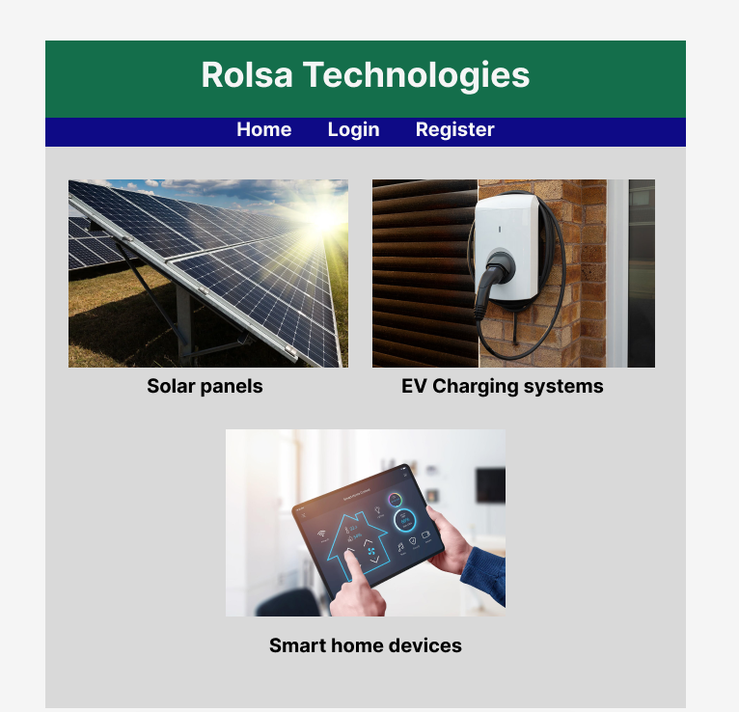
Home page where the navigation bar is clearly displayed for the user to see it is also displaying to products that Rolsa Technologies has to offer. It also has company Displayed and could implement a company logo but currently that is a non-functional requirement.

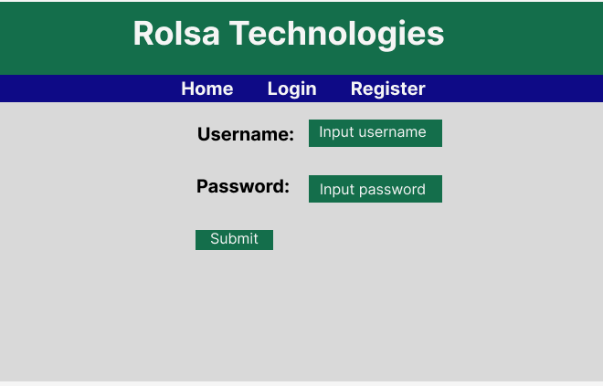
An easy and simple login page for the user to be able to login to their accounts on the website, it is made easy so that it can suit all ranges of users that may access this website.

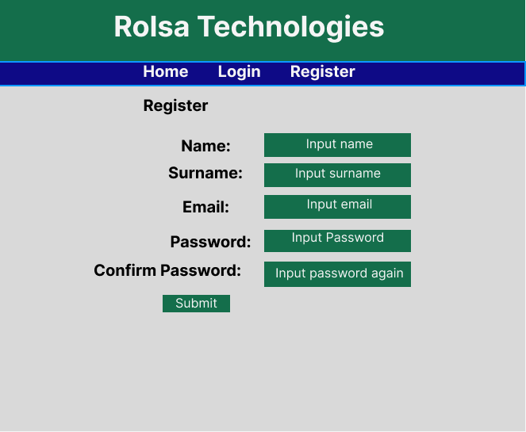
Same with the register page design.

Tips

1. Start with Clear Requirements
- Functional: What your system must do (monitoring, EV charging, automation, dashboards).
- Non-functional: How it should perform (reliability, security, scalability).
- Define KPIs early — they’ll guide design, testing, and optimisation.

2. Modular System Design
- Break your system into clear modules:
  - Device Layer: sensors, EV chargers, smart appliances
  - Communication Layer: IoT protocols (MQTT, HTTP)
  - Application Layer: energy management algorithms, scheduling
  - User Interface: mobile/web dashboards
- Modular design makes debugging, scaling, and future upgrades easier.

3. Choose the Right Hardware
- For EV and smart home integration:
  - Sensors: smart plugs, energy meters, battery monitors
  - Controllers: microcontrollers or SBCs (Raspberry Pi, ESP32)
  - Actuators: relays for appliances, smart switches
- Check compatibility with your communication protocols and standards.

4. Focus on IoT & Communication
- Use lightweight, reliable protocols like MQTT for real-time updates.
- Ensure secure communication: TLS/SSL encryption.
- Consider edge processing to reduce cloud dependency and latency.

5. Optimise for Energy Efficiency
- Implement smart scheduling for EV charging and appliance usage.
- Prioritise renewable energy usage (solar/wind) over grid electricity.
- Use predictive analytics for energy forecasting if possible.

6. Build a User-Friendly Dashboard
- Include real-time monitoring, historical trends, and alerts.
- Offer manual override for automation.
- Use visualisations like graphs, gauges, and status indicators for clarity.

7. Test in Stages
- Start with simulation or single-device testing.
- Integrate devices gradually: smart home → EV → energy storage → dashboard.
- Validate each KPI as you go.

8. Security & Reliability
- Implement user authentication and role-based access.
- Ensure data integrity and backup critical logs.
- Plan for failure recovery: automatic reconnection of devices, safe EV charging shutdowns.

9. Scalability & Extensibility
- Design system to add new devices easily.
- Use modular code and APIs to allow future integration with third-party services.
- Ensure database can handle growing logs and historical data.

10. Documentation & Visualisation
- Keep a system diagram, device map, and data flow chart.
- Document communication protocols, API endpoints, and energy optimisation logic.
- A visual design helps when presenting or debugging the system.

